2025 Petersburg Colt Show August 9th, 2025
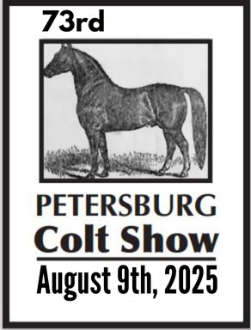
1 - Walking & spotted weanling fillies.
2 - Walking & spotted yearling fillies.
3 - Model mare & gelding open.
4 - Walking & spotted weanling with youth exhibitors.
5 - Walking & spotted yearling colts.
6 - Model stallion open.
7 - Walking & spotted yearling with youth exhibitors.
8 - Walking & spotted weanling colts.
9 - Model mare & gelding with youth & amateur exhibitors.
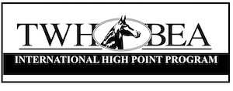
10 - Walking & spotted yearling championship.
11 - Walking & spotted weanling championship.
12 - Model championship.
Gates open at 3:00 show to start at 5:00
Entry fee is $20.00.
Perpetual trophies are awarded for all 3 championship classes.
Youth are considered 17 and under.
Negative coggins is required.
Spectator admission is free, but donations will be accepted.
Persons on federal disqualification cannot transport horses to this show and may only participate as a spectator.
Neither the Lincoln Farmers’ Cooperative, the Petersburg Colt Show, The Petersburg CCC, its organizers, officials, volunteers, contractors, or other employees of the show will be responsible for any article of any kind or nature that may be lost, destroyed or stolen, nor liable for any injury sustained to horse, exhibitors, spectators or employees of exhibitors. The foregoing shall be included as a condition of entry.
Under Tennessee Law, an equine professional is not liable for an injury to or the death of a participant in equine activities resulting from the inherent risks of equine activities, pursuant to Tennessee Code Annotated, Title 44, chapter 20. 44-20-103. Limitation on liability for injury or death of participant Except as provided in §44-20-104, an equine activity sponsor, an equine professional, or any other person, which shall include a corporation or partnership, shall not be liable for an injury to or the death of a participant resulting from the inherent risks of equine activities. Except as provided in §44-20-104, no participant or participant's representative shall make any claim against, maintain an action against, or recover from an equine activity sponsor, an equine professional, or any other person for injury, loss, damage, or death of the participant resulting from any of the inherent risks of equine activities

