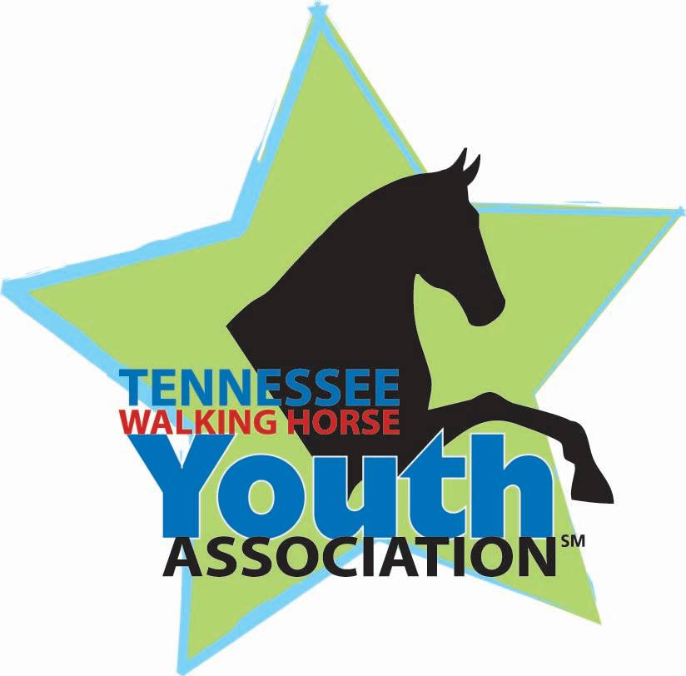
Would you like to serve on the
2025
TWHYA Youth Board?

- Must be a current TWHYA Youth Member.
- Must be 11 years old as of January 1, 2025.
- Must have access to an email address for communication.
- Must be able to attend scheduled meetings (in person or via Zoom), volunteer at TWHBEA functions, and promote TWHYA in your area.
- Board members must participate in at least one TWHYA program and/or contest.
- One representative will be elected for every region.
- Must have parental permission to serve.
Name_________________________________________________________
Address_______________________________________________________
City___________________________State_______Zip_________________
Birthdate______________________Telephone No.___________________
Email address__________________________________________________
Applicant’s Signature___________________________________________
Parent/Guardian’s Name_______________________________________ Parent/Guardian’s Signature_____________________________________
Parent/Guardian’s Email(if different)______________________________
Position Applied For: (Check Box)
President-shall preside at all meetings of TWHYA, report status of TWHYA activities via social media pages and at the TWHBEA Annual meeting, and serve on the TWHBEA Youth Committee (minimum of 2 years) *Term of office- 1 year
Vice President-shall attend all meetings, and in the absence of the President, perform all coordinating duties *Term of office- 1 year
Secretary-shall attend all meetings and record minutes *Term of office- 1 year
Treasurer- shall attend all meetings, examine and track financial requirements for TWHYA specific projects, and monitor TWHYA memberships *Term of office- 1 year
Regional Representative- shall attend all meetings, support TWHYA projects in their respective region and report back to TWHYA board their findings *Term of office- 1 year
Below please explain why you are interested and how you would best serve in this position if elected:
____________________________________________________________________________________________________________________________________________________________________________________________________________________________________________________________________________________________________________________________________________________________________________________________________________________________________________________________________________________________________________________________________________________________________________________________________________________________________________________________________________________________________________________________________________________________________________________
Return this form by January 24, 2025 to Jessica Ozburn jozburn@twhbea.com

