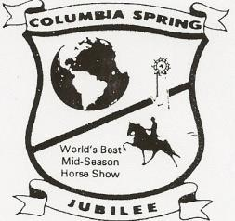73rd Annual

Columbia Spring Jubilee

May 30– June 1, 2024, 6:00 pm

Maury County Park

921 Lion Parkway Columbia, TN 38401

Judges: Scott Beaty, Scotty Brooks, Justin Jenne

**Enter Online: www.entermywalkinghorse.com**

**May 30**

1. **Riders’ Cup Jeff Givens Memorial Model Open**

2. TWHBEA Youth Medallion Pleasure (canter)

3. Amateur Three Year Old Mares & Geldings

4. Trail Pleasure Racking, Amateur/Juvenile, Optional Tack

5. Amateur Lite-Shod

6. **Riders’ Cup Two Year Old Mares & Geldings**

7. TWHBEA Youth Medallion Performance (Canter)

8. Amateur Two Year Old Stallions

9. Amateur Mares & Geldings

10. Youth Show Pleasure Riders 17 & Under

11. **Riders’ Cup Park Pleasure Five & Under**

12. Amateur Four Year Old Stallions

13. Specialty Action Racking

14. **Riders’ Cup 15.2 & under**

15. Amateur Park Pleasure (optional tack)

16. **Riders’ Cup Four-Year Old Mares & Geldings**

17. WHTA Families & WHTA Auxiliary Members

18. Racking Stake

19. **Riders’ Cup Three Year Old Stallions**

**May 31**

20**.** Amateur Park Performance

21. Amateur Four Year Old Mares & Geldings

22. **Riders’ Cup Young Trainers, 35 & Under**

23. Country Speed, Juvenile riders 17 & under

24. Amateur Five Year Old Mares & Geldings

25. **Riders’ Cup Show Pleasure Five & Under**

26. Amateur Riders On Walking Stallions

27. Country Speed

28. **Riders’ Cup Open Show Pleasure**

29. Amateur Five Year Old Stallions

30**.** Specialty Action Racking, (Amateur/ Juvenile rider)

31. Cliff Loftin Memorial Juvenile, 11 & Under

32. **4 & Under Speed Racking**

33. Racking (Amateur or Juvenile Rider)

34. Novice Amateur ***(No Blue ribbon for rider in 2024 within show hio)***

**3****5.** Speed Racking, Keg Shod

36. Amateur Riders On Walking Ponies

37. **Riders’ Cup Three Year Old Mares & Geldings**

38. **Riders’ Cup Open Specialty Stake**

39. Andy Adkins Memorial Juvenile, 17 & Under

**June 1**

Stick Horse, 6 & Under (Ribbons only)

40. Lead Line Pony, Riders 6 & Under

41. Fine Harness Open

42. **Riders’ Cup Aged Mares & Geldings, Specialty**

43. **Riders’ Cup Walking Yearlings- Fillies & Geldings**

44. Amateur Two Year Old- Mares & Geldings

45. Amateur Owned & Trained (No professional training in 90 days)

***46. Riders’ Cup Wayne Tharp Memorial Two Year Old Stallions***

47. Amateur Lady Riders on Mares & Geldings

48. **Riders’ Cup Walking Yearlings- Stallions**

49. Speed, Open Shod, Juvenile Riders 17 & Under

50. Amateur Show Pleasure

51. **Riders’ Cup Park Performance**

52. Amateur Three Year Old Stallions

53. Amateur Riders, 50 & Over

54. Speed, Amateur Riders

55. Amateur Riders on Walking Horses (Canter)

56. **Riders’ Cup Larry McCrory Memorial**

**Four Year Old Stallions**

57. Youth Walking Ponies, Riders 17 & Under

58. Amateur 15.2 & Under

59. Open Speed Racking

60. **Riders’ Cup Walking Horse Championship Stake (Canter)**

|  |  |  |  |  |  |  |  |  |  |  |  |
| --- | --- | --- | --- | --- | --- | --- | --- | --- | --- | --- | --- |
|  | **\*\*\* All Classes are Specialty unless otherwise noted** | | | | | | | | | | |
|  |  |  |  |  |  |  |  |  |  |  |  |
|  |  |  | 1st | 2nd | 3rd | 4th | 5th | 6th | 7th | 8th |  |
|  | Classes 2, 7 | NO ENTRY FEE |  |  |  |  |  |  |  |  |  |
|  | All Regular Classes | $40 Entry Fee | $100 | $50 | $40 | $30 | $20 | R | R | R |  |
|  | Rider’s Cup | $50 Entry Fee | $100 | $50 | $40 | $30 | $20 | R | R | R |  |
|  | Class 37 & 59 | $70 Entry Fee | $200 | $80 | $70 | $60 | $50 | R | R | R |  |
|  | **Show management must collect on behalf of S.H.O.W:** | | | | | | | | | |  |
|  | **Padded horses $30 per class, Youth Medallion classes $5 per entry** | | | | | | | | | |  |
|  | **Pleasure horses $30 per entry plus $5 each additional inspection of same horse.** | | | | | | | | | |  |
|  |  |  |  |  |  |  |  |  |  |  |  |

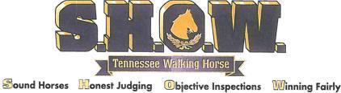**Sponsored by: The Maury County Horseman’s Association. For information call, 931-797-3139**

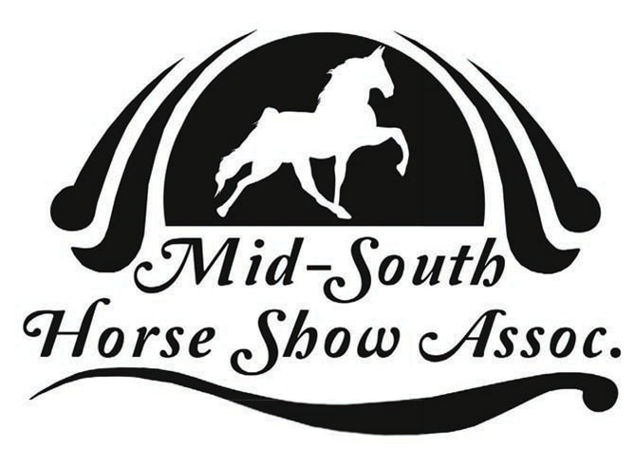

The sponsoring organization and show management will not be responsible for any accidents or theft. Management reserves the right to change the order of classes and to cancel any class if entries are not adequate. A negative Coggins Test is required for all horses on show grounds. Any horse turned down by DQP will forfeit entry fee. DQP decisions are final. Persons in federal disqualification cannot transport horses to this show and can participate only as a spectator.