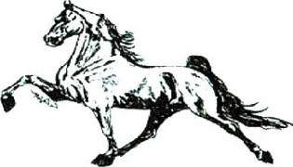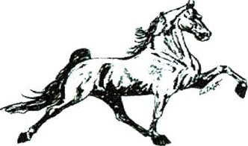Midwest Walking Horse Trainer Association

### Aug 13, 2022 7:00pm

**Bolivar Saddle Club**

**Bolivar, MO**

**Judge: Rick Morrison Entry Fee $25 per class**

**1st - $25, 2nd - $15, 3rd. - $10, 4th & 5th - Ribbon**

1. Lead Line **Class 16 and 31** No Entry Fee /There will be a $10.00 DQP Fee only

1. Weanling
2. Model
3. 4 and Under Gaited Pleasure (Optional Tack)

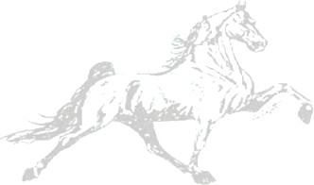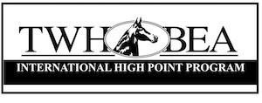

1. Racking Country Pleasure (Optional Tack)
2. Juvenile Specialty 17 and under Walking Horse
3. Lite Shod Walking Horse (Optional Tack)
4. 2 Year Old Walking Horse
5. Pleasure Racking - Western
6. Juvenile 12-17 Gaited Pleasure (Optional Tack)
7. Amateur Owned and Trained Gaited Pleasure (Optional Tack)
8. Juvenile 11 and under Gaited Pleasure (Optional Tack)
9. *50 a*nd Over Amateur Specialty Walking Horse
10. Park Pleasure Walking Horse (Optional Tack)
11. Novice Horse Gaited Pleasure (Optional Tack)
12. Youth Medallion Performance
13. 3 Year Old Walking Horse
14. Juvenile Trail Pleasure Walking Horse (Optional Tack)

****10 minute break****

1. 15.2 and Under Amateur Specialty Walking Horse
2. Trail Pleasure Racking Horse - Western
3. 4 Year Old Walking Horse
4. Amateur Trail Pleasure Walking Horse
5. Country Pleasure Walking Horse (Optional Tack)
6. Amateur Specialty Walking Horse
7. Gaited Pleasure (0ptional Tack)
8. Show Pleasure Walking Horse
9. 50 and Over Gaited Pleasure (Optional Tack)
10. Racking Specialty Action
11. Open Trail Pleasure Walking Horse (Optional Tack)
12. Park Performance Walking Horse
13. Youth Medallion Pleasure
14. Walking Horse Specialty Open
15. Racking Horse Open Championship
16. Open Walking Horse (Canter)

**Affiliations:** MWHTA / HAWHA / SWMHSA / RHBAA / Appropriate attire for Western and English Classes **Not Responsible for Accidents / loss or Injury/NO REFUNDS ON DISQUALIFICATIONS** For Show Information Contact: David Turnbow 573-727-4876 or Madalyn Thompson 816-256-1404

## Special Thanks to Our Sponsors

## 4 – J Land & Cattle The 1 – J Nickel

## Action Automotive – St. Robert, MO

## Tammy Boykin Lloyd & Linda Stith

## Rosalie Jones & Marvelene Kusewitt Arvest Bank

## Curlee Stables Altamoor Stables

## Easton & Emberly Spotts Ryker Thompson

## Wagon Wheel Stables – Shelly Parker & Lester White

## Abby Curlee, LMT Harper Thompson

## David Turnbow Abby White Rick Roberson

## Northwest Animal Clinic - Turchi, DVM

## Racking Horse Breeders Association of America